American Charitable Watersport Activities Foundation 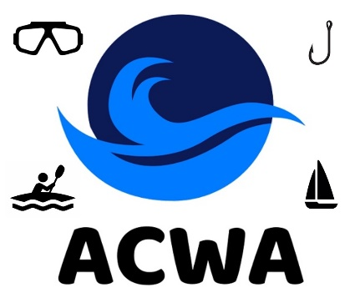
2026 Supporter Registration
$20
The “American Charitable Watersport Activities Foundation” (ACWA) was established by SCUBA divers on March 31, 2023. ACWA is recognized by the IRS as a 501(c)(3) public non-profit charity. Staffed by non-paid volunteers, all ACWA’s administrative expenses and some of its donation support, is provided annually by members of our community who chose to become “Supporters”.
Supporter Registration for the “American Charitable Watersport Activities Foundation” (ACWA) is open to Clubs and Individuals who reside in the United States of America.
“Supporters” on record for 2023, 2024 & 2025 are listed on a “Supporter Master List” and need not complete this form. They continue their charity efforts with their 2026 payment of $20 to ACWA’s treasurer - Mark Leiserowitz (contact information listed below).
New “Supporters” need to complete this form to provide ACWA with contact and IRS reporting information. To join the others who believe in supporting the operations of a charity targeting our community. Please print legibly as e-mail addresses will be utilized to keep supporters abreast with the charity’s status and your name as identified below, used in any future donation reporting required by you or the IRS.
Make Checks Payable To: ACWA, c/o Mark Leiserowitz, 5205 De Milo Dr., Houston, Texas 77092

Name: _____________________________________Phone / Cell Phone: ________________________
E-Mail: _______________________________________________________________
Signature: ____________________________________________ Date: ________________________

